

Gran’s adventures <https://learnenglishkids.britishcouncil.org/grammar-videos/grans-adventures>

Present perfect – experiences –Με τον Present Perfect περιγράφουμε εμπειρίες

I have been to London, He has flown on a plane, We have watched “Harry Potter”

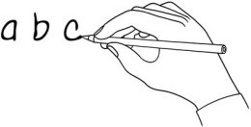

# What’s the word?

Write the word under the pictures.

|  |  |  |  |
| --- | --- | --- | --- |
| ~~school~~ | pyramid | souvenirs | Eiffel Tower |
| eat | hungry | pizza | Italy |

|  |  |  |  |
| --- | --- | --- | --- |
|  |  |  |  |
|  | school |  |  |
|  |  |  |  |
|  |  |  |  |

# True or false?

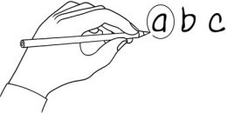Watch the video ον <https://learnenglishkids.britishcouncil.org/grammar-videos/grans-adventures>. Mark true or false for these sentences.

|  |  |  |
| --- | --- | --- |
| a. Max is going to Cairo. | *true* | *false* |
| b. Gran hasn’t been to Egypt. | *true* | *false* |
| c. John hasn’t been to Egypt. | *true* | *false* |
| d. Gran hasn’t seen the Eiffel Tower. | *true* | *false* |
| e. Gran has eaten sushi. | *true* | *false* |
| f. Gran has been to Tokyo. | *true* | *false* |



# Fill it in!

Write ‘have’ or ‘haven’t’ in the sentences so they are **true for you**. Write four (4) more sentences!

1. I *have* eaten pizza.
2. I eaten sushi.
3. I been to Tokyo.
4. I seen the Eiffel Tower.

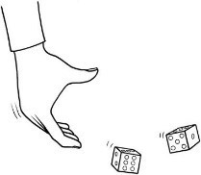

# Play a game in class!

1. Write three sentences about you, four true and one false.
2. Read your sentences to the class. They must guess which one is false!
3. Now listen to your friends’ sentences. Guess which sentence is false!

|  |
| --- |
| Write 3 sentences about you.  ex. *I have never read a book* |
|  |

[www.britishcouncil.org/learnenglishkids](http://www.britishcouncil.org/learnenglishkids)

© British Council, 2017 The United Kingdom’s international organisation for educational opportunities and cultural relations. We are registered in England as a charity.